Project 16-1: Progress Bar

User interface
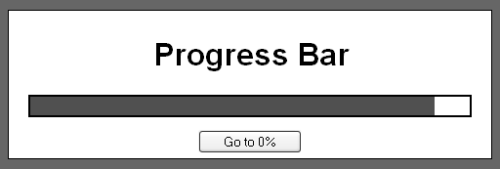

Operation
- This application implements a progress bar.
- When the page loads, the progress bar is at 0% and the button reads “Go to 100%”.
- If the progress bar is at 0% and the user clicks on the button, this application moves the progress bar from 0% to 100%. Then, it changes the text on the button so it reads “Go to 0%”.
- If the progress bar is at 100% and the user clicks the button, this application moves the progress bar from 100% to 0%. Then, it changes the text on the button so it reads “Go to 100%”.

Specifications
- The width of the progress bar is set by CSS.
- The progress bar should be updated every 40ms. The progress bar should take approximately four seconds to go from 0% to 100%.
- When the progress is between 0% and 39%, the bar should be red. Between 40% and 79%, it should be yellow. At 80% and above, it should be green.
- Use the jslib_dom_ready.js and jslib_event.js libraries from chapter 14.

Hint
When updating the progress bar, you’ll need to check to see if the progress bar is at its goal. If it is, the update function has finished. If it’s not, the update function moves the progress bar in the direction of the goal and then calls itself again after a short delay.

